Phase I and Phase II Results – Arizona (AZ)

A. Introduction
Phoenix and its suburbs are among the hardest hit by the foreclosure crisis. Avondale, just west of Phoenix, doubled in residents between 2000 and 2005. Now residents are unable to sell their houses except at fire-sale prices. In a case study done by the Wall Street Journal, appraisers valued a house at $132,000 for a $103,000 mortgage, sight unseen, before the housing bubble burst. Under foreclosure the house recently sold for $18,000.

Arizona is a state plagued with negative home equity. In the Town of Maricopa, 75% of all homeowners owe more on their mortgages than the current value of their homes. This is a substantial number compared to the national estimate of 18%.

The Obama administration’s government assistant program will only help you refinance your mortgage if you owe between 80% and 105% of your home's value. Since Arizona is one of the worst hit areas where homes prices have plummeted far below the level of many mortgages, the program will not offer much reprieve to Arizona residents. The Federal stimulus plan offers up to an $8,000 tax credit for anyone who hasn't owned a home for at least three years and the new home remains the buyer's "main home" for at least 36 months after the purchase date. However, this is unlikely to alleviate the

"The foreclosure problem in Arizona is only going to get worse," comments Fred Karnas, the new director of the Arizona Department of Housing. Arizona is currently the state with the nation's third-highest foreclosure rate. On the demand side, there has been a recent drop in building permits for homes across metropolitan Phoenix.

Moreover, the state economy has dependence on three industries that led the nation into recession: construction, housing and financial services. Analyst’s forecast an increase in home prices and sales is unlikely to happen until 2012.

B. Plot of Lagged Predictors vs. HPI (simple returns)
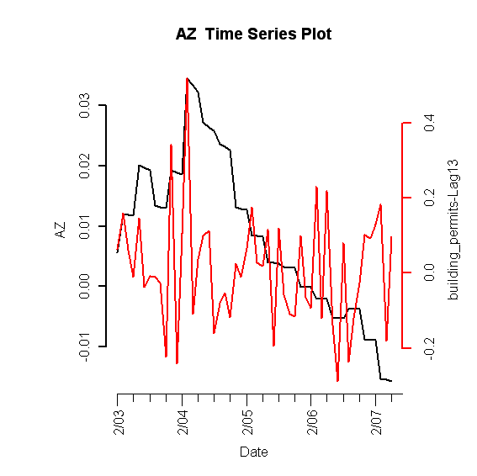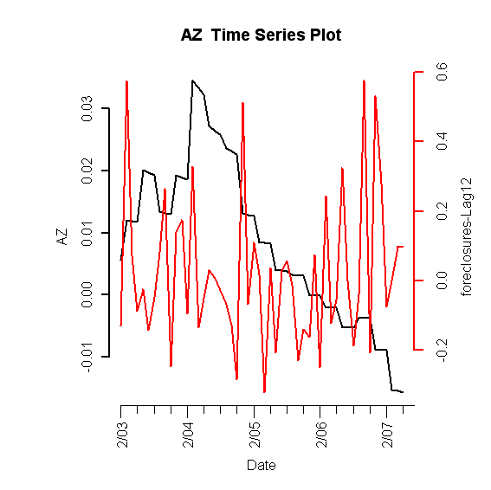

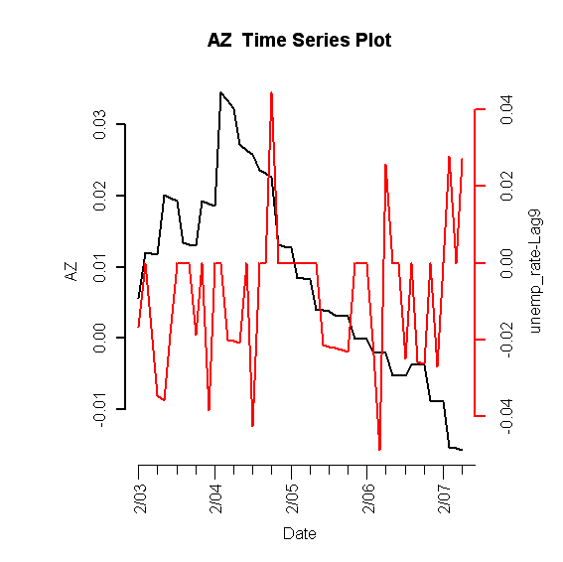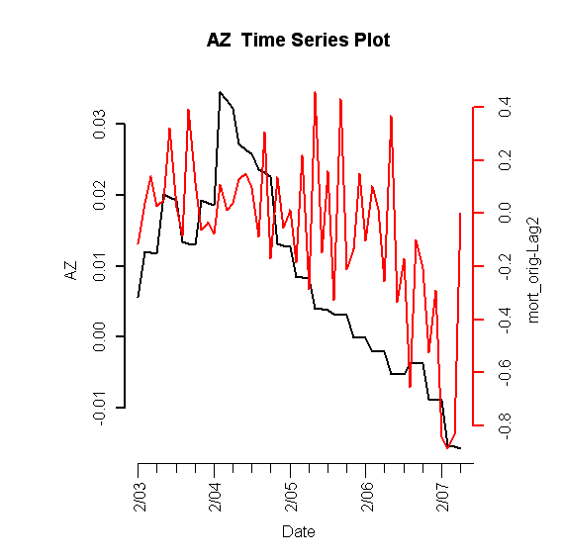
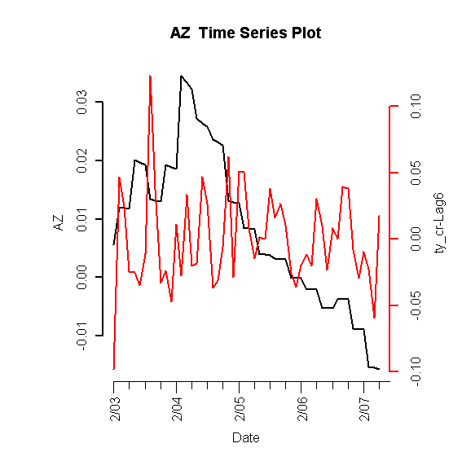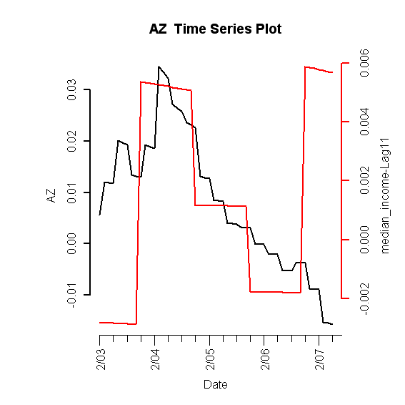

Figure I.1: Lagged predictors vs. Arizona HPI

C. Final Multivariate Model

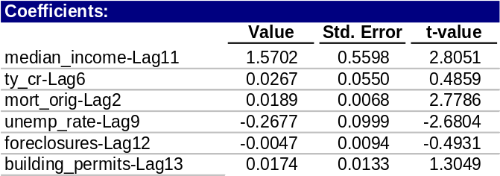
Table 1: Fitted drift model

1. Phase I: Drift Model

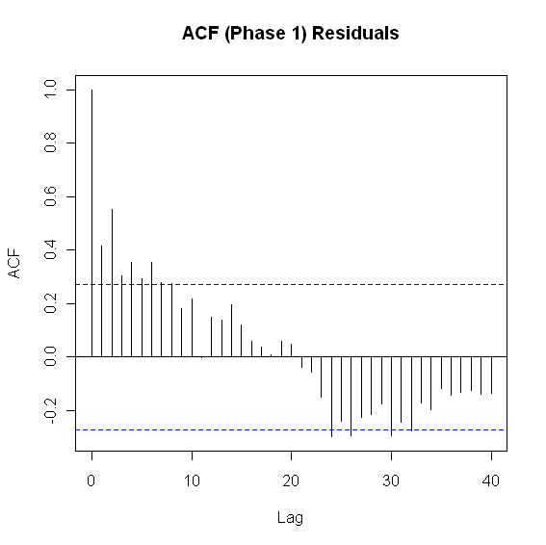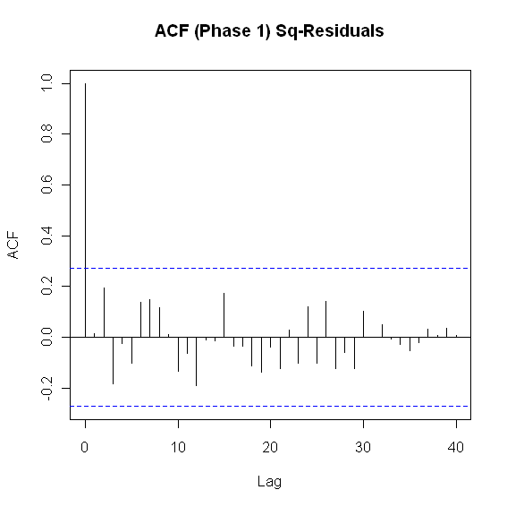

Figure I.2: ACF of residuals (left) and squared residuals (right) of fitted linear model

2. Phase II: Volatility Model

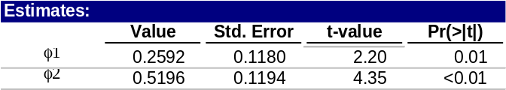
Table 2: Idaho fitted volatility model

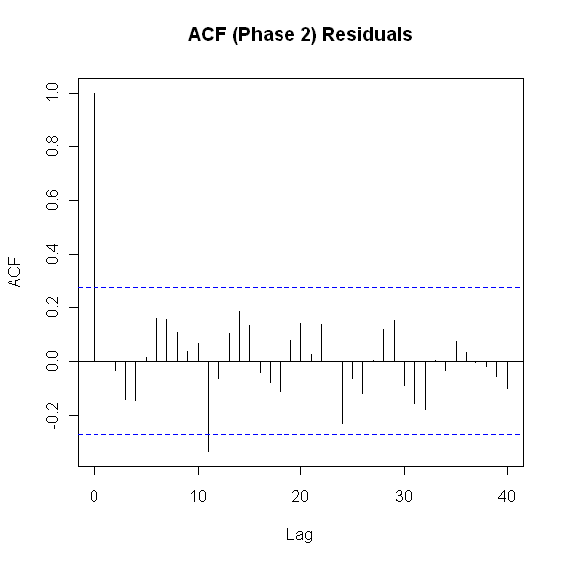

Figure I.3: ACF of residuals (left) and squared residuals (right) of the Phase II model for Idaho

3. Model Checking Diagnostics

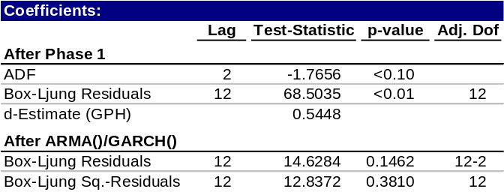
Table 3: Statistical test results for complete model

D. Fitted vs. Actual Plots

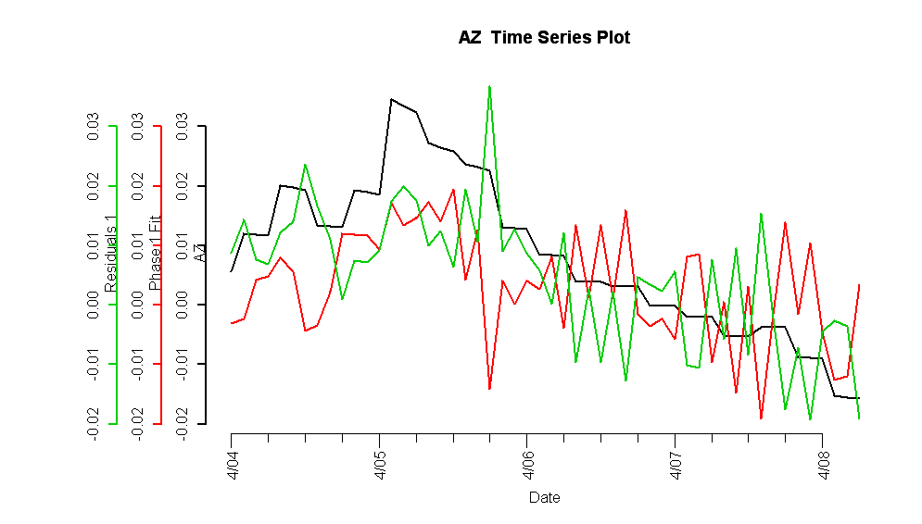
Figure I.4: Fitted Phase I vs. Arizona HPI and residuals

Figure I.5: Complete fitted model vs. Arizona HPI and residuals

E. Forecasts
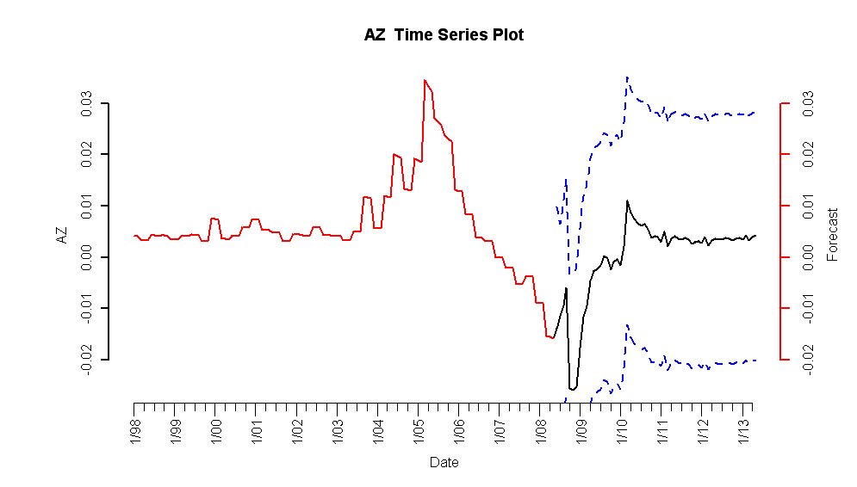
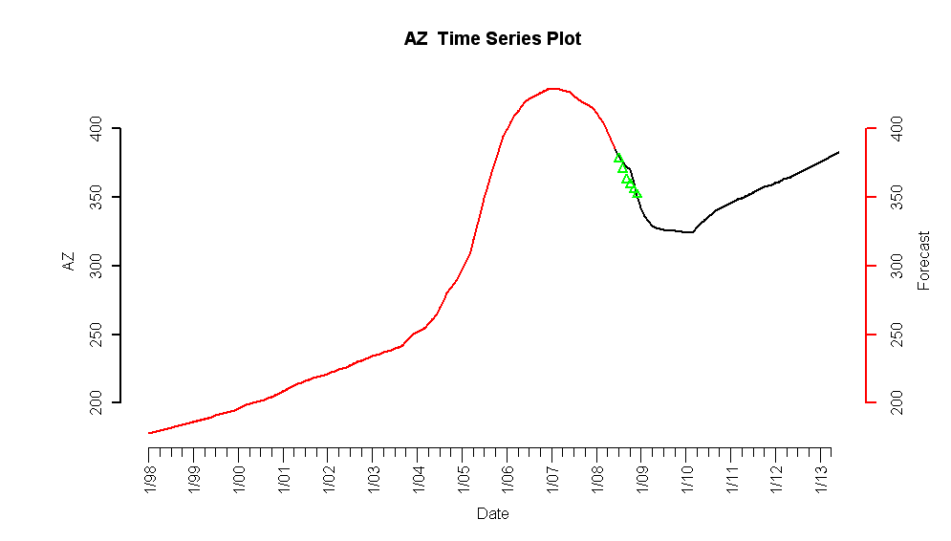

Figure I.6: 5-year forecasted simple returns (top) and forecasted HPI (bottom)

F. Interpretation of Forecasts

The model forecasts indicate a decrease in the HPI until 2010, at which point the simple returns move into positive values. This is in consensus with analyst forecasts and validates our model, given that the realized increase in building permits will have a smoother uptick. Furthermore, the third and fourth quarter 2008 observed values are similar to our forecasts.

